User TestRail Website Usage

V1.0

10/31/2016

Shawn Yan

**Contents**

1. INTRODUCTION 3

1.1 What is TestRail 3

1.2 Major Features 3

2. Getting started with TestRail 5

2.1 The dashboard 5

2.2 Projects and milestones 5

2.3 Test cases and suites 5

2.4 Test runs and tests 6

2.5 Test plans and configurations 9

2.6 Reports 9

2.7 Detail Report 9

2.8 Machine Status 10

# INTRODUCTION

## What is TestRail

* + 1. TestRail is a web-based test case management tool. It is used by testers, developers and team leads to manage, track and organize software testing efforts. TestRail allows team members to enter test cases, organize test suites, execute test runs and track their results, all from a modern and easy to use web interface.
    2. Official documents link: <http://docs.gurock.com/start>
    3. Lattice Regression Framework link: <http://linux-d50553/testrail>

## Major Features

* + 1. **Manage test cases, suites and test runs**

The traditional way of managing and documenting test cases on paper, in wikis, bug tracking tools or general document management systems quickly reaches its limits. TestRail enables you to create, manage and organize test cases and suites within an optimized user interface and application structure.

* + 1. **Boosting testing productivity**

TestRail's todo lists, filters and email notifications help coordinate test runs and increase the productivity and responsibility of testers. The goal is to make sure that every team member knows his tasks at all times and that team leads can assign new tasks to testers depending on their workload.

* + 1. **Real-time insights into your testing progress**

To make important project decisions, it is critical to have access to detailed information about the testing progress and test results. Questions such as “How many percent of a test run have we successfully completed?”, “How are we progressing on the upcoming milestone?” or “Which tests have been executed in the past 24 hours?” can only be answered efficiently by using a comprehensive test case management software such as TestRail, and TestRail makes these details readily available.

* + 1. **Organize and track software testing efforts**

The organization and coordination of multiple parallel tests, be it for different projects or releases, is often complex and time-consuming. To not lose track of your testing efforts, TestRail helps you manage important software-specific data and structures such as project milestones and makes it easy to integrate with bug tracking tools.

* + 1. **Developed UI scripts to support customers’ requirements**

The UI scripts include but not limited to:

1. add default configuration/template for suite/case/run, etc.;
2. pause/stop/play a run;
3. syntax check of user inputs;
4. retest cases with status filter;
5. browse detail running log for the test;
6. machines status check.

# Getting started with TestRail

## The dashboard

After logging in to TestRail, the first page you usually see is the dashboard. The dashboard provides you with an overview of available projects, recent project activities and your todos. When you navigate to a project (by clicking on a project title), you switch to the project view and land on the project's overview page, showing project details such as test suites, active test runs, project activity and so on. Whenever you need to switch to another project, just return to the dashboard by clicking the link in the upper left corner.

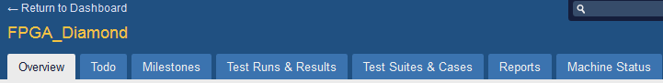

## Projects and milestones

Projects are the main organizational unit in TestRail. It is generally recommended to create a TestRail project for every real software project you want to manage within TestRail. All other data such as test suites, runs, test results, milestones etc. are directly associated with a specific project. You can also add your project milestones to TestRail.

A milestone can be any project milestone you deem to be important, such as a planned public software release, an internal test version or a new beta release for an important customer. Once you have added your milestones to TestRail, you can assign test runs to specific milestones.

Assigning test runs to milestones has the advantage that you can easily track the milestones' test results and progress separately. Especially if you are working on multiple milestones in parallel or if you have many test runs active at the same time, managing milestones within TestRail is a great help.

## Test cases and suites

A test case in TestRail consists of a description of the test's prerequisites, a list of test steps and the expected result. A test case can ideally be verified by a single tester in a short period of time and confirms a specific functionality, documents a task or verifies a project artifact.

In TestRail, test cases are organized into test suites. A test suite is a collection of test cases and is often created for specific project modules or areas. How you organize your test suites depends on the size of your project. If you have a lot of test cases for a project module, it is recommended to further break down your test suites and create suites for specific features or functionality. Ideally, a test suite consists of 50-1000 test cases.

A test suite has its own general configuration which records some overall options for the test cases in this suite, such as Subversion repository and suite path, command options, etc. Generally the test case’s configuration has higher priority than the suite’s configuration except of command options.

To further organize test cases, test cases of a suite can be grouped into so-called sections. Sections are used to organize test cases into groups to make it easier for testers to identify related cases.

For example, if you use multiple test cases to verify a specific application dialog or web page, these test cases should be grouped in a section. Depending on how complex your project is and how fine-grained your test cases are, a section should ideally consist of 10-50 test cases.

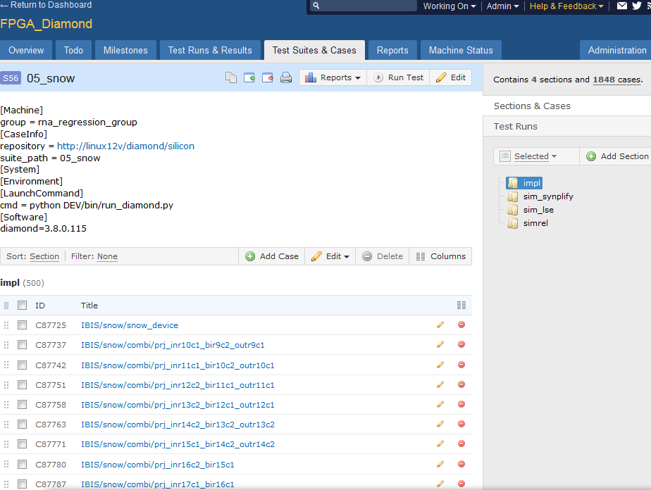

## Test runs and tests

To run a test and enter test results for the cases you added, you start a test run for a particular test suite. While a test suite is just like a plan that specifies how an application is tested, a test run is an actual test you are conducting.

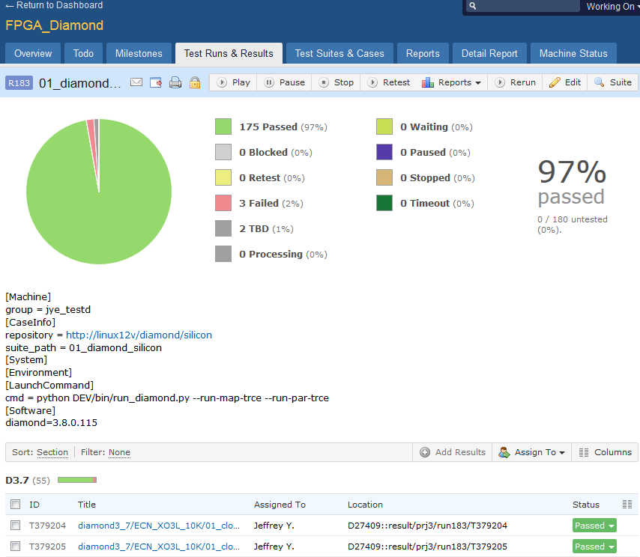

* + 1. Add Test Run

You can create a run by selecting a test suite. In the next page, you can add more customer configurations.

Default run name is suite name, you can use any meaningful name for your run.

Milestone is a track name for a run.

It’s very convenient to modify the test run’s configuration as you wish, and the “CheckClient” will tell your which clients have been selected to launch your run currently.

You can run all test cases in this suite by “Include all test cases”, otherwise “Select specific test cases” will show a page to select cases by different filters.

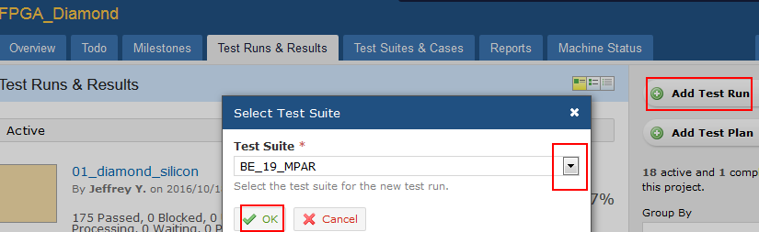

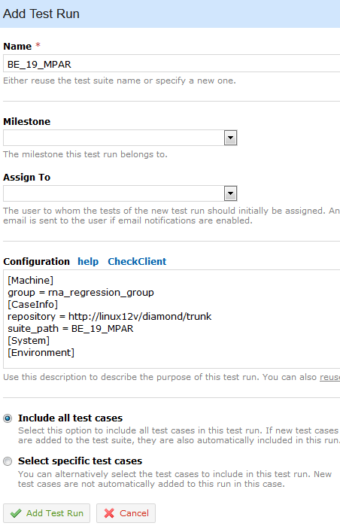

* + 1. Pause/stop/play a test run

The button for “pause/stop/play” is: .

If you want to pause the run and will be recalled in the later time, you can click pause button. In a short time the test case which status is Waiting will be changed to Paused. Click “Play” button will continue to run this run.

If you want to stop a run, you can click stop button. In a short time all test cases’ status will changed to Stopped. Click “Play” button will rerun all test cases in this run.

* + 1. Retest cases in a test run

Click  will provide a page for you to select some cases and the platform will rerun them. The filter is the test cases status name.

* + 1. Rerun

The platform will create a totally new run which will inherit all configurations from current run. And the rerun function provides some filter for the new run.

* + 1. Browse a test run

You can browse with the URL: http://linux-d50553/testrail/index.php?/projects/runs/$run_id

## Test plans and configurations

When you need to manage multiple test runs and configurations for a single project, TestRail's test plans come in handy. A test plan allows you to start multiple test runs at once, either if you have many test suites or if you want to test against multiple configurations (where a configuration can be anything you need to test your project against, such as different operating systems or web browsers).

To create a test plan, simply click the Add Test Plan button from the Test Runs & Results page. Now just select one or more test suites from the sidebar to add them to the plan. Just like you do with a single test run, you can configure all properties of the test runs such as the name, the cases you want to include and so on.

You often have to test a specific test run against multiple configurations such as operating systems or web browser versions. To make it easier to create a separate test run for each configuration combination, you can specify and select all configurations for your test runs within a plan. To do this, simply click the Select Configurations link of a run and select or add your configurations.

## Reports

To be done later.

## Detail Report

To be done in the ’16 Q4.

## Machine Status

To be done in the ’16 Q4.